Identify common energy sources (i.e. coal, natural gas, oil, wind, solar, hydro)
Pillar 2 C (Grades 4th -8th)

Website: https://www.studentenergy.org/map?gclid=Cj0KEQjwmIrJBRCRmJ_x7KDo-9oBEiQAuUPKMudYEz_sdALkUbKRGoP7WUkaXBwpJUhurUB4S5x7EQMaAsV88P8HAQ
Hands on: Build a solar oven and have kids cook s’mores
Play Power Up https://climatekids.nasa.gov/power-up/

Build a Solar Oven
Digital Learning: Watch YouTube video about wind turbines: https://www.youtube.com/watch?v=PQyJrqenWRI
Using iPads, Play Power Up https://climatekids.nasa.gov/power-up/

Student Learning Objectives
- Understanding alternative energy
- Understanding the connection to a career in environmental engineering

Tools, Equipment, and Supplies
- Cardboard pizza box (the kind delivered pizza comes in)
- Box knife or scissors
- Aluminum foil
- Clear tape
- Plastic wrap
- Black construction paper
- Brown Paper
- Paint Sticks
- Lab Quest with thermometer probe
- Graham Crackers
- Marshmallows
- Miniature Chocolate Bars

Instructors will prepare boxes ahead of time

Use a box knife or sharp scissors to cut a flap in the lid of the pizza box. Cut along three sides, leaving about an inch between the sides of the flap and the edges of the lid. Fold this flap out so that it stands up when the box lid is closed. 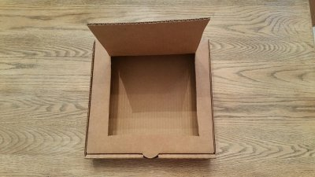

Interest Approach Have you ever heard the expression that it's so hot out you could fry an egg on the sidewalk? Have you ever wondered if it's true? You’ll find out! Today we will use the sun's energy to heat up a tasty treat with this simple solar oven! We’ll also talk about how this activity could lead to a career in environmental engineering and you’ll learn about absorption, insulation, and the sun's energy.

Today we’re going to construct a solar oven using a pizza box, tin foil, newspaper, and black construction paper. We’re going to make s’mores using the energy from the sun. Can anyone guess how this will work? (Wait for responses)

The heat from the sun is trapped inside of your pizza box solar oven, and it starts getting very hot. Ovens like this are called collector boxes, because they collect the sunlight inside. As it sits out in the sun, your oven eventually heats up enough to melt cheese, chocolate, or cook a hot dog! How does it happen? Rays of light are coming to the earth at an angle. The foil reflects the ray of light, and bounces it directly into the opening of the box. Once sunlight has gone through the plastic wrap, it heats up the air that is trapped inside the box. The black paper absorbs the heat at the bottom of the oven, and the newspaper ensures that the heat stays where it is, instead of escaping out the sides of the oven.

Your solar oven can reach about 200° F on a sunny day and will take longer to heat things than a conventional oven. Although this method will take longer, it is very easy to use, and it is safe to leave alone while the energy from the sun cooks your food.

Even on partly cloudy days there may be enough heat and light from the sun to slow cook a special dish. Here are a few tips for having success with your solar oven:
- Reposition your solar oven when needed, so that it faces direct sunlight. You should be checking periodically on your oven, to make sure it is in the sun.
- Make sure that the foil-covered flap is reflecting light into the pizza box, through the plastic-covered window.

Ok let’s start! Step by step instructions are taped to your table. To save time, we’ve cut a window in each pizza box already.

Step 1. Cover the inner side of the flap with aluminum foil so that it will reflect rays from the sun. To do this, tightly wrap foil around the flap, and then tape it to the back, or outer side of the flap. 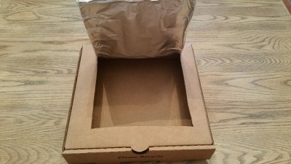

Step 2. Use clear plastic wrap to create an airtight window for sunlight to enter into the box. Do this by opening the box and taping a single layer of plastic wrap over the opening you made when you cut the flap in the lid. Leave about an inch of plastic overlap around the sides and tape each side down securely, sealing out air.
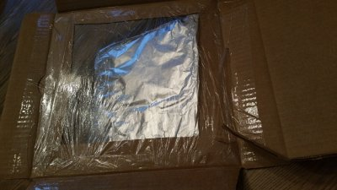
Step 3.
Line the bottom of the box with black construction paper—black absorbs heat. The black surface is where your food will be set to cook. 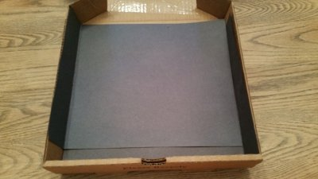

Step 4.
To insulate your oven so it holds in more heat, roll up sheets of paper and place them on the bottom of the box. Tape them down so that they form a border around the cooking area. It may be helpful to also tape the rolls closed first. The newspaper rolls should make it so that the lid can still close, but there is a seal inside of the box, so air cannot escape.

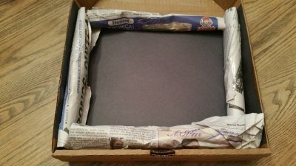
Step 5.
The best hours to set up your solar oven are when the sun is high overhead. Place your box in a sunny spot and adjust the flap until the most sunlight possible is reflecting off the aluminum foil and onto the plastic-covered
window. Use a paintstick to prop the flap at the right angle.
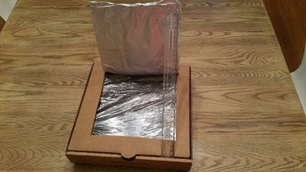
Step 6.
Place the thermometer inside your oven and then close the lid. Measure the temperature when you start cooking and measure the temperature when your s’mores is done cooking. How much did your temperature increase? How long did it take for your s’mores to cook?

*NOTE: DON’T LET YOUR OVEN EXCEED 275 DEGREES F! 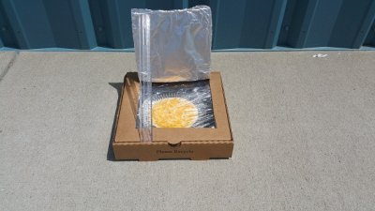

Review/Summary
What temperature was your oven when you started cooking? What was the temperature when your s’mores was done? How much time did your s’mores take to cook?

Today we learned about absorption, insulation, and the sun's energy. Can anyone tell me a career path that might use these concepts?
(Alternative Energy Engineer for example, discovering how to improve methods for capturing solar energy)

Optional extensions:
- Have students figure the rate of temperature increase per minute
- Have students suggest ways that their s’mores could have cooked faster (place the oven on absorbent blacktop for example)

Alternate Activity:

Activity 6.1.2 Solar Array

Purpose:
There are multiple forms of energy available today. In this activity we will look at solar energy, and its use for renewable energy sources. Students will build a small solar panel, and measure the power produced.

Materials per pair of students:
- LabQuest2
- Voltage sensor
- Current sensor
- Solar panel
- Sheet of white paper
- Lamp with incandescent bulb

Procedures:
- Students will receive and read through the handout.
- Have students predict light intensity and quality on the solar cell.
- Connect the current sensor to channel one and the voltage sensor to channel two of the LabQuest2.
- From the Meter Screen select Sensors.
- In the Sensor menu, select Sensor Setup.
- Select Channel 1 where the Current Sensor is connected and select Current.
- Select Power Amp Current. Choose OK.
- In the Sensor menu, select the Voltage Sensor.
- Set the voltage to +/-10V. Choose OK.
- Position the lamp so that it can shine directly on the solar panel.
- Connect the red wire of the solar cell to the red connector of the current sensor.
- Connect the red wire from the voltage sensor to the black connector of the current sensor.
- Connect the black wire of the voltage sensor to the negative lead of the solar cell.
- Position the light 4 inches from the solar cell to simulate direct sunlight.
- Record the volts and amps produced in Table 1.
- Position the light about 12 inches from the solar cell to simulate indirect lighting.
- Record the volts and amps produced in Table 1.
- With the light positioned 12 inches from the solar cell place a white sheet of paper between the light and solar cell. Covering the solar cell with paper will simulate a cloudy day.
- Record the volts and amps produced in Table 1.
- Turn off the light and cover solar cell to simulate darkness.
- Record the volts and amps produced in Table 1.
- Calculate the power output for each source and record in Table 1.
- Power (watts) = Voltage (volts) x Current (amps)
- Clean up the work area as instructed by your teacher.

