Discover how American Farmers Keep Food Safe
Pillar 2 A (Grades 4th – 8th)

Pillar 2 A. The Relationship between agriculture and food, fiber, and energy

Websites: http://extension.psu.edu/food/safety/educators/food-safety-lessons-for-middle-school-students

http://www.agclassroom.org/teacher/matrix/lessonplan.cfm?lpid=431&grade=3,6&author_state=0&search_term_lp=%20food%20safety

Chain of Food

Interest Approach
Students will explore the path food takes along the Farm-to-Table Continuum. They will begin on the farm and investigate food safety issues during processing, transportation, at restaurants and supermarkets, and finally, in their own homes. Teams will identify how food can become contaminated along the continuum and develop and present strategies for preventing contamination at each step.

Materials
- Dr. X and the Quest for Food Safety video
- Food Safety Farm-to-Table Illustration
- Cooked hot dog on a bun
- Grated cheese
- Relish
- Banana
- Paper plate
- Poster board
- Markers

Advance Preparation
Put the grated cheese and relish on top of the cooked hot dog in the bun. Place the hot dog and the banana on a paper plate and set the plate where the students will see it when they enter the room.

- Essential Files (maps, charts, pictures, or documents)
- Farm to Table Continuum

Everyone along the Farm-to-Table Continuum plays a role in keeping our food safe from harmful bacteria. If a link in this continuum is broken, the safety of our nation’s food supply is at risk. There are food safety precautions, including the 4 Cs of Food Safety, that help prevent contamination of food at each step.

Essential Links
- Science and Our Food Supply website
- Dr. X and the Quest for Food Safety Video

Enriching Activities
- Using the Economic Research Service website, look on a map and calculate how many miles your favorite food traveled from one of the countries to your state. For example, how many miles did the banana travel from where it was grown to your state?
- Visit the Economic Research Service website, find your favorite food, and see how many different countries it comes from. Or, select a country and see how many foods we get from that country.

Suggested Companion Resources
- Beef Blasters (Activity)
- Lose a Million Bacteria The Game (Activity)
- The 12 Most Unwanted Bacteria (Activity)
- Food Safety Music (Multimedia)
- How Safe is Your Salad? (Multimedia)
- The Great Food Fight (Multimedia)
- Virtual Food Safety Labs (Multimedia)
- Antimicrobial Wash for Fresh Produce (Website)
- Fight Bac! Food Safety Education (Website)
- Food Safety A to Z Reference Guide (Website)
- What's In My Food? (Website)

Vocabulary
E. coli: a bacterium commonly found in the intestines of humans and other animals, where it usually causes no harm; some strains can cause severe food poisoning, especially in old people and children
compost: decayed organic material used as a plant fertilizer
salmonella: a foodborne pathogen sometimes found in the intestines of chickens. It can be passed on in the meat and also inside the chicken’s eggs

Background Agricultural Connections
Everyone along the Farm-to-Table Continuum plays a major role in keeping our food safe. If a link in this continuum is broken, the safety and integrity of our nation’s food supply can be threatened. There are many places on a farm that can be contaminated by harmful bacteria, so farmers have to make sure that the areas where food is handled are kept clean and at the right temperature. There are many innovations on the farm that help prevent the growth of bacteria — like special areas for washing vegetables, refrigerated storage areas for milk and eggs, and portable sanitation in fields.
more ...

Interest Approach – Engagement
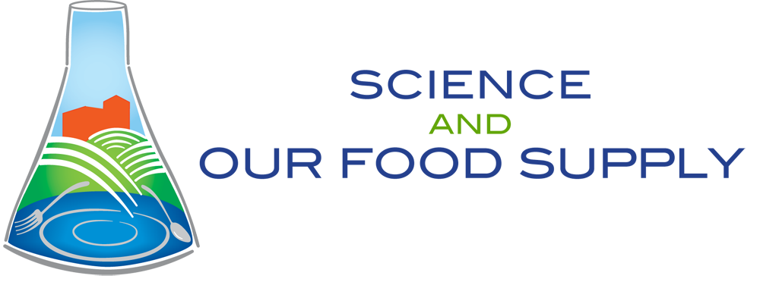
- 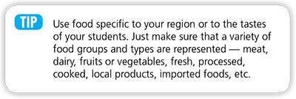
- As students enter the classroom, they’ll likely notice the food you’ve set out. (See details in Materials section.) Look surprised when someone mentions the hot dog or banana. Then go over, pick up the hot dog and banana, and ask, "Does anyone know where these foods came from?" Let the students speculate for a few minutes. Then comment, "I confess, I put them there, but let’s look at who else played a part in getting the hot dog, bun, cheese, relish, and banana to us." Allow the students to review the Farm-to-Table Continuum steps (farm, processing, transportation, retail, and home) which can be taught from the attached document and/or the preparatory lesson, Understanding Bacteria.
- Tell the students, "You will be learning about people you never dreamed had a role in getting this food to you."
- Ask, "What does science have to do with the farm?" Give the students time to make a few suggestions.
- Then ask, "What do you think could happen to food along the Farm-to-Table Continuum that could affect the safety of our food supply?" List their answers on the board.
- Explain, "Food doesn’t start at the supermarket or restaurant. Today, we’ll trace the path of food along the Farm-to-Table Continuum and discover some of the ways it can become contaminated. Then we’ll develop and present strategies for preventing contamination at each step."

Procedures

- Let’s tune in to the first step on the Farm-to-Table Continuum. While watching this module, keep these questions in mind:
  - Would you feed a baby chick bacteria? Why or why not?
  - What’s compost all about, and how is it relevant to food safety on the farm?
  - Tune in, and take notes. Show video Module 2 — Farm (Time: 4 minutes).
- Divide the class into 5 groups. Assign a food to each group (hot dog, bun, cheese, relish, and banana).
- Have students begin researching their assigned food. Using poster board let each team trace their food from the farm to the table. This will serve as the “first draft” of their food journey chart. Remind students that some foods are imported from other countries, so be sure to trace them from their origin. (Students can find out where a variety of foods come from by visiting the Economic Research Service site.)
- Post the charts around the classroom, and keep them up throughout the lesson. As the teams learn more about the continuum, they can add to or change the information.
- Challenge the students to include all the people involved at each step (e.g., farmers, produce pickers, milkers, truckers, grocery workers, shelf stockers, restaurant workers, etc.). Create a competition that focuses on which team can identify the most people.
- For each person the team identifies, they must include what that person does to help control the spread of bacteria. Students should label all the places where contamination of their food may occur, then write a strategy for preventing that particular contamination. Encourage them to use the 4 Cs (as taught in Understanding Bacteria) to help develop the strategy. For example, in the video they learned about the potential contamination of crops at the farm — the compost must reach at least 131° F (55° C) to ensure that the compost doesn’t contaminate the crops. One suggestion could be to develop ways for compost to reach high enough temperatures to kill pathogenic bacteria and to make the compost safe.
- At the end of this lesson or the entire food safety unit, have each team share its food journey chart with the class. The team that traces the banana should also address the global issue. Ask students, "What do these foods have in common? Where do the similarities and differences occur along the Farm-to-Table Continuum?"
- Have each team add up the number of people they identified. Which food had the most people involved in the Farm-to-Table Continuum? Why?

Concept Elaboration and Evaluation

- Why did Dr. Elsasser feed a baby chick bacteria? (Good bacteria are fed to baby chicks, so there is no room left for the bad bacteria to grow.)
- What did you find interesting about Dr. Elsasser’s job?
- We also met Dr. Patricia Millner, another scientist who conducts research for keeping our food safe on the farm. What did she say about compost, and how is it relevant to food safety on the farm? (It’s heat again. If enough heat can be generated from the compost, it will kill harmful bacteria, especially E. coli O157:H7. The compost is then safe to use on crops that we will eat.)
- How does Dr. Millner’s research benefit us? (It will help keep our food safe.)

Sources/Credits
The Science and Our Food Supply Curriculum was brought to you by the Food and Drug Administration Center for Food Safety and Applied Nutrition and the National Science Teachers Association.
- FDA Education Team Leader Food Safety Initiative: Marjorie L. Davidson
- FDA Science and Our Food Supply Project Director: Louise H. Dickerson
- FDA/NSTA Associate Executive Director and Science and Our Food Supply Program Director: Christina Gorski
- FDA/NSTA Science and Our Food Supply Program Assistant: Jill Heywood

