The relationship between agriculture and animals
Pillar 3 C. Identify reasons livestock safety is a priority for farmers
(9th – 12th Grade)

Website: http://www.agclassroom.org/teacher/matrix/lessonplan.cfm?lpid=62
Video: https://vimeo.com/40536817

Build it Better

Purpose
In this lesson students investigate animal handling preferences and design a cattle corral system that is durable, efficient, and effective. Students will also discover the skills needed to be an agricultural engineer.

Materials
For the class:
- Internet connection
For each group:
- Various Construction Materials: Ruler, scissors, glue, poster board, craft sticks, construction paper, chenille stems, cardboard, cereal boxes, toothpicks, fabric, and more, for each group
For each student:
- Build It Better Design Plan handout
- Build It Better Design Resources handout
- Build It Better Design Grading Rubric

Essential Files (maps, charts, pictures, or documents)
- Build It Better Design Plan handout
- Build It Better Design Grading Rubric
- Build it Better Design Resources

Vocabulary
Agricultural engineer: the branch of engineering that deals with the design of farm machinery and the location and planning of farm structures
Behavior: the way in which an animal acts in response to a particular situation or stimulus.
Environment: the surroundings or conditions in which a person, animal, or plant lives or operates
Handling: the manner in which an animal is treated
Livestock: domesticated animals raised in an agricultural setting to produce commodities such as food and fiber
Well-being: the contentment of an animal measured by indicators including behavior, physiology, longevity, and reproduction

Did you know? (Ag Facts)
- Temple Grandin has done extensive work on the design of handling facilities and has worked with companies worldwide—from the United States and Canada to Europe, Mexico, Australia, New Zealand and other countries.¹
- Today, half the cattle in the U.S. and Canada are handled in equipment she designed for meat processing plants.¹
- Agricultural engineers help design methods of farming that decrease labor, therefore increasing a farmer's ability to produce food.²

Background Agricultural Connections
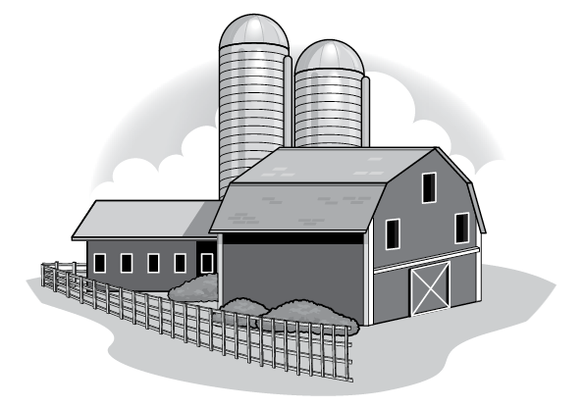
This lesson is one in a series of 5 related lessons to promote the development of STEM abilities and critical thinking skills, while fostering an appreciation for the people involved in livestock production. For more information about what STEM is, why it's important, and how it can be implemented in your classroom, watch the video, What is STEM? The curriculum includes real-life challenges for students to investigate, inquiry-based labs, and opportunities to plan and construct models.

Interest Approach – Engagement
- Discuss with your students the following vocabulary words: well-being, environment, behavior, and livestock.
- Ask your students the following questions and lead a class discussion:
  - "What are some elements of animal welfare that should be considered when caring for animals?" (their necessities of life such as food, water, and shelter are met)
  - "What are the benefits to the farmer for having calm and content animals? What are the benefits to the consumer?" (calm animals are easier for the farmer to work with and generally produce more milk, meat, or eggs.)
- Inform your students that in this lesson, they will:
  - Investigate animal handling preferences.
  - Use online resources to research solutions to real-life problems.
  - Plan and construct models.
  - Design a cattle corral system that is durable, efficient, and effective.
  - Learn about the skills needed to be an agricultural engineer.

Procedures
- Help students start thinking like engineers by sharing this scenario:
  - Maxine has an aging German shepherd named Frankie. Maxine needs to take Frankie to the veterinarian for his annual check-up. Since Frankie has gotten older, he can no longer get into Maxine’s truck independently. Unfortunately, Maxine broke her arm in a skiing accident last week and cannot lift him. It’s 9:45 and Maxine needs to think of a quick, safe, and efficient way to load Frankie into the truck for his 10 o’clock appointment. Put your engineering thinking cap on and let’s solve the problem!
- Brainstorm and record student ideas for loading Frankie into the truck. Remind students to think about keeping Frankie calm and safe while accomplishing the desired goal. Tell students that agricultural engineers apply basic science and engineering principles to design solutions to challenges in agricultural production. Highlight the responsibilities and skills of an agricultural engineer:
  - Agricultural engineers may design agricultural machinery and facilities using drawings and models.
  - Agricultural engineers use their knowledge and skills to solve real-world problems.
  - Agricultural engineers need to be creative with the ability to envision new designs such as tractors and their implements, livestock handling systems, irrigation systems, and animal housing.
  - They must understand science and engineering concepts
- Tell students that in today’s activity they will be designing a corral system for cattle. Temple Grandin is a legend in the world of animal agriculture. She is known for her extraordinary understanding of the animal mind which has assisted her in designing animal handling systems—especially in cattle production. Temple Grandin gives credit to her autism, a condition that makes social interactions with other people challenging, for helping her understand how animals think and respond to their environment.
- Show the first minute and 40 seconds of a video that introduces Temple Grandin and her work. There are also a variety of videos available on the Temple Grandin YouTube channel. Grandin also improved slaughterhouse design, so you may wish to filter which video students watch.
- Review the Build It Better Design Plan handout with the class. The objective of the project is to design a model livestock corral and alley way for loading livestock onto trucks for transportation. The goal of your design is to keep the animals calm and safe. Your group will be graded on the effectiveness, efficiency, and durability of your design. As groups research and plan their design, they should record their progress on the Build It Better Design Plan handout. Each group must have teacher approval for their plan before starting construction. Introduce students to the available construction materials and divide students into groups.
- Once students have completed their models, groups will present their design to the class in a three-to-five-minute presentation. Students should highlight research findings, design characteristics, modifications, and their construction procedure. You may wish to grade the models using the Build It Better Design Grading Rubric or have students complete the rubric to grade their peers.
- Conclude the lesson by discussing the reflection questions on the Build It Better Design Plan handout.

Concept Elaboration and Evaluation
After conducting these activities, review and summarize the following key concepts:
- Farmers and ranchers care for their animals by providing food, water, and shelter to keep them comfortable.
- Advances in technology decrease the labor necessary to produce our food on farms. Agricultural engineers develop and design these tools and machines.
- Agricultural engineers develop many types of tools and machines to use on farms. Some are simple such as a specific type of gate or animal feeder. Others are very complex machines such as tractors and harvesters.
- Ethics are a belief of what is right and what is wrong. Ethics guide the decisions of farmers in ranchers in raising animals to produce food and fiber.

Variation:
- Instead of creating a three-dimensional model, students can create a three-dimensional sketch using an online program, such as Google SketchUp.
- Distribute graph paper and challenge students to create a scaled diagram of their design.
- If students are not yet comfortable researching topics online, review the recommended resources prior to the lesson and print out specific documents that will help them identify design characteristics. Otherwise, teachers may use an LCD projector or SMART Board™ to demonstrate how to search the Web and identify important information.
- Challenge advanced students by giving them specific information such as type of truck, age, size or gender of cattle, and the distance between the animal housing and loading area.
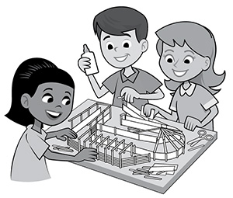
Suggested Companion Resources
- Agricultural Engineering Video (Multimedia)
- Careers in Agriculture Videos (Multimedia)
- You're Hired! (Multimedia)
- Sprout 2 - Careers (Booklets & Readers)
- Feed, Nourish, Thrive (Careers Website) (Website)

Sources/Credits
This lesson was funded in 2012 by the United States Department of Agriculture’s National Institute of Food and Agriculture through the Secondary Education, Two-Year Postsecondary Education, and Agriculture in the K-12 Classroom Challenge Grants Program (SPECA). Graphics submitted by California Foundation for Agriculture in the Classroom.
Executive Director: Judy Culbertson
Illustrator: Erik Davison
Layout and Design: Nina Danner

Sources:
- http://www.grandin.com/
- http://factfile.org/10-facts-about-agricultural-engineering

